Pickets and Picket Fence Quote Request Form
Please complete the below form for all loose pickets and picket fencing enquires and email to sales@replas.com.au
A sales team member will be in touch and supply a quote within 3 working days.
Customer name

Email and contact details
Please include State
Project name, location and timeframe
Delivery Location:

Availability of a forklift for unloading

Total lineal metres of project including all gates
Number of pedestrian access gates | 900mm width | QTY:
Number and width of  vehicle access gates  maintenance gates | Width: | QTY:
 | Width: | QTY:
Size of Pickets  (Standard picket heights are 800mm, 900mm or 1200mm, non-standard sizes can be supplied subject to MOQ) | Picket Height:
Picket Thickness (either 12mm or 18mm):
Picket Width (standard width is 62mm):
Gap between the pickets | Either 20mm or 45mm
Style of Pickets,  Please nominate | 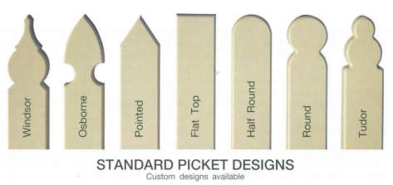
Colour of pickets  Please nominate:  Colour of posts, gate frames and rails  Please nominate: | Standard colours are:  Off White (= Colorbond Surfmist ®)  Smooth Cream (= Colorbond Classic Cream ®)  Mist Green (= Colorbond Pale Eucalypt ®)  Caulfield Green (= Colorbond Cottage Green ®)  Slate Grey (= Colorbond Woodland Grey ®)  Charcoal (= Colorbond Night Sky ®)  (Other colours can be supplied subject to MOQ)

